Chapter 7, Problem 41.

Using Fig. 7.108, design a problem to help other students better understand the step response of an RC circuit.
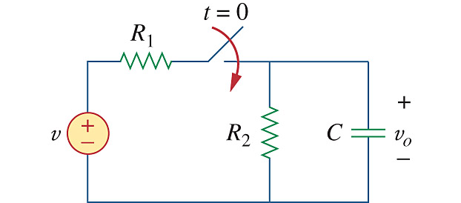

Figure 7.108
For Prob. 7.41.

